HDOC Day 15
1. Algorithm
- Start the program.
- Display the menu and read the choice.
- Input a positive integer.
- Use switch-case to perform the selected operation.
- Check whether all digits are even or all digits are prime.
- Display the result.
- If choice is 0, exit; otherwise repeat the menu.
- Stop the program.
2.Code
#include <stdio.h>

int main()
{
int ch,n,d,flag;

printf("1. Even digits\n2. Prime digits\n0. Exit\n");
printf("Enter choice: ");
scanf("%d",&ch);

if(ch==0) return 0;

printf("Enter positive integer: ");
scanf("%d",&n);

switch(ch)
{
case 1:
flag=1;
while(n)
{
d=n%10;
if(d%2) flag=0;
n/=10;
}
if(flag) printf("All digits are even");
else printf("All digits are not even");
break;

case 2:
flag=1;
while(n)
{
d=n%10;
if(d!=2&&d!=3&&d!=5&&d!=7) flag=0;
n/=10;
}
if(flag) printf("All digits are prime");
else printf("All digits are not prime");
break;

default:
printf("Invalid choice");
}
return 0;
}
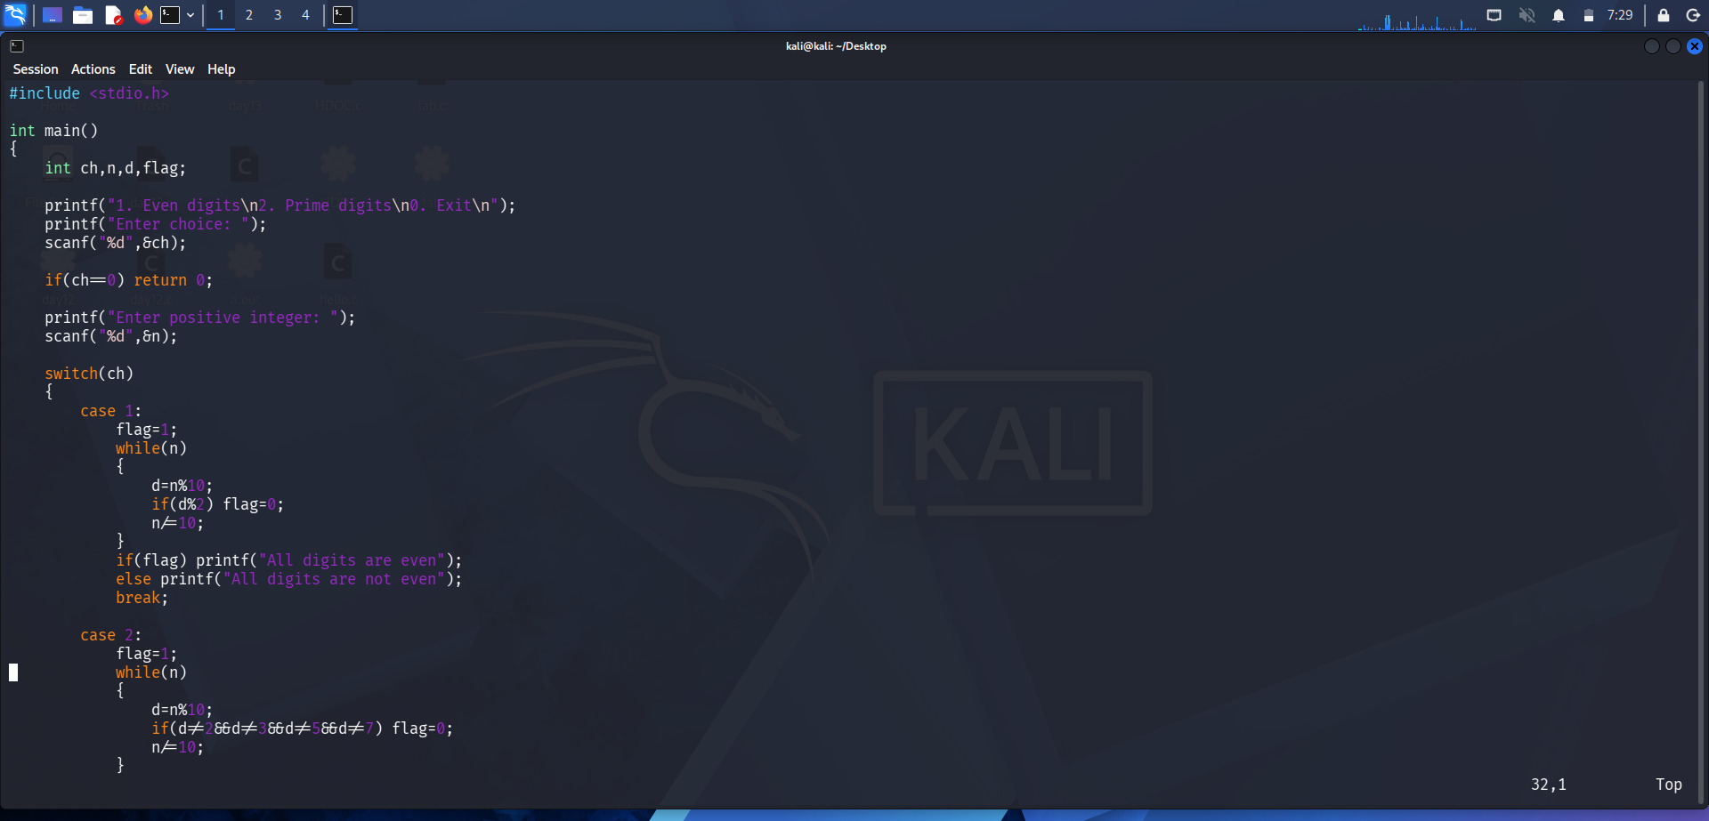
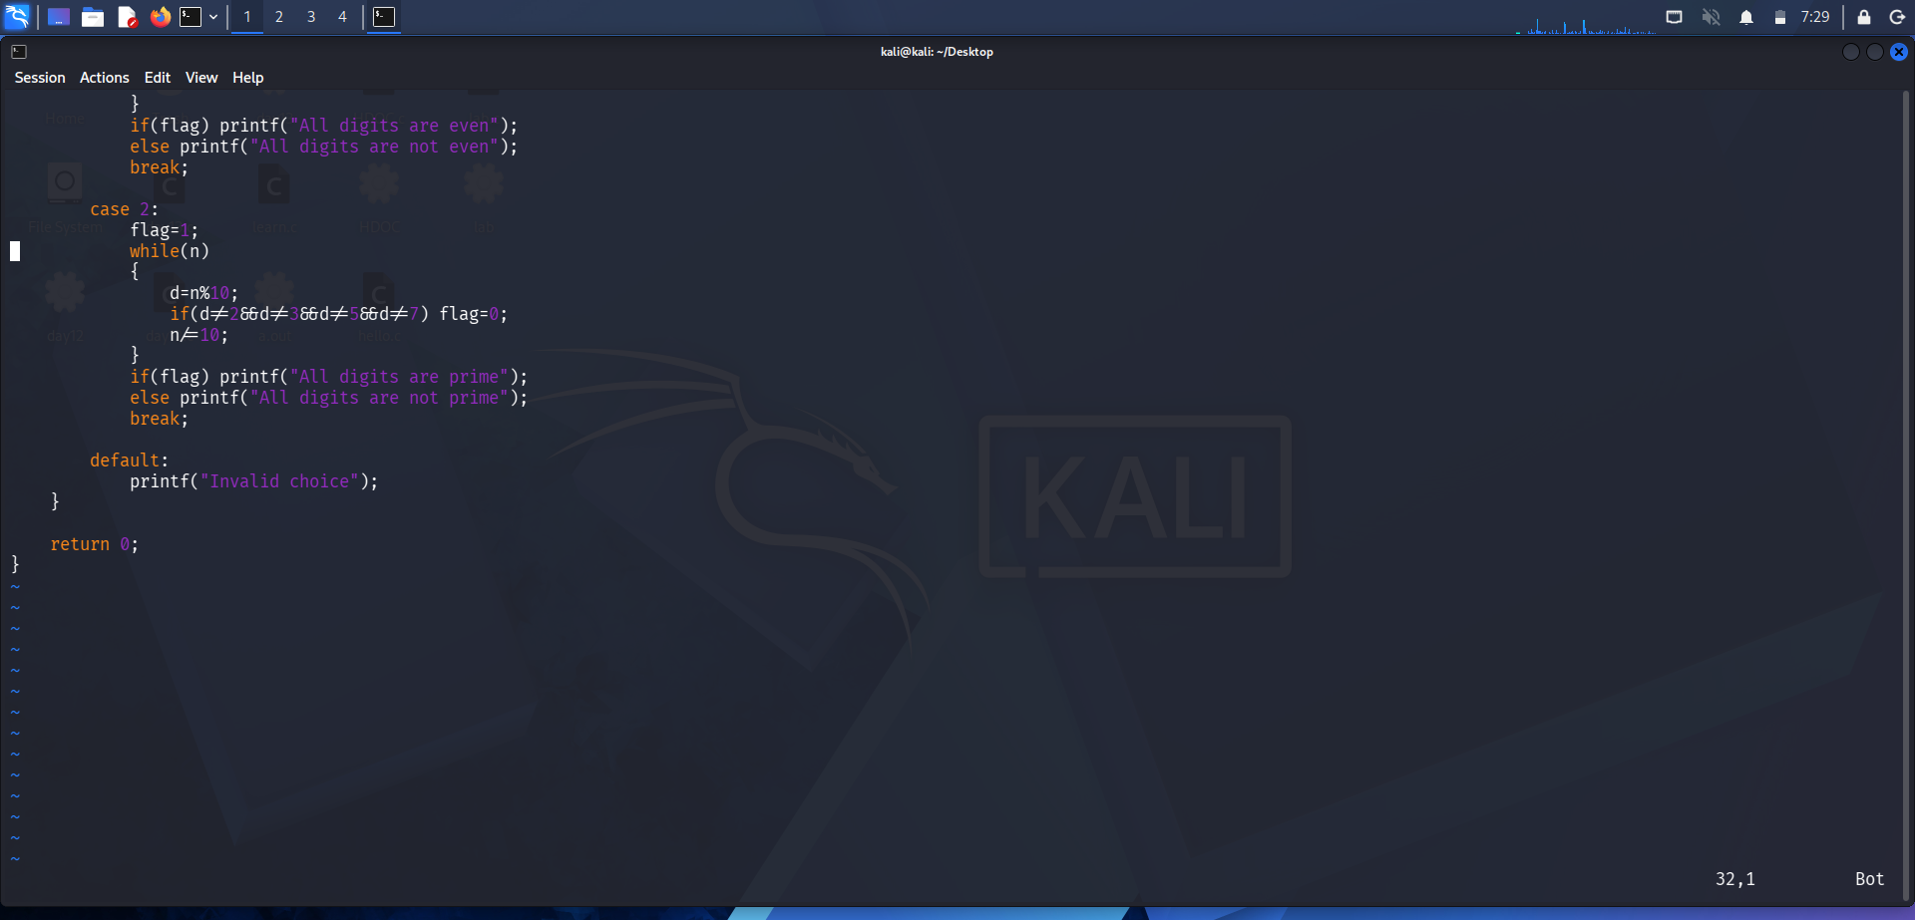
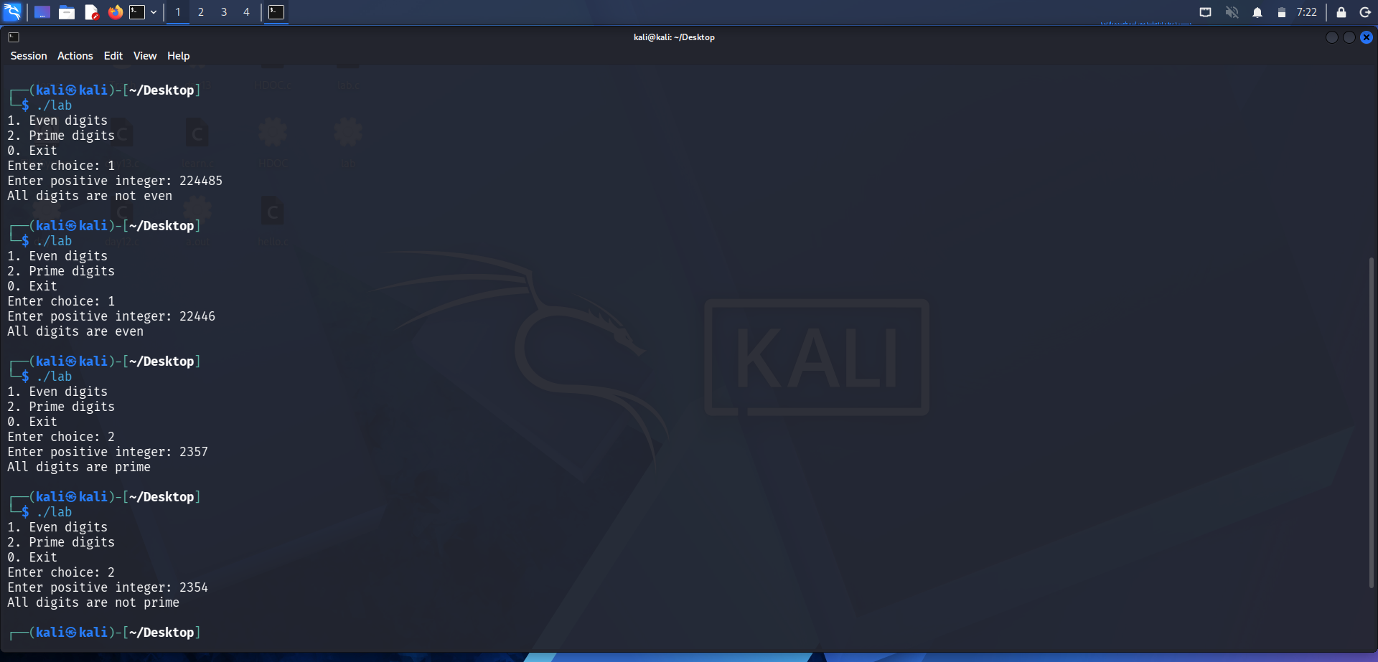
3.Test case table:
Test case | Input | choice | Expected output | Actual output
1 | 224485 | 1 | All digits are not even | All digits are not even
2 | 22446 | 1 | All are even | All are even
3 | 2357 | 2 | All digits are prime | Al digits are prime
4 | 2354 | 2 | All digits are not prime | All digits are not prime

Result :
All pass .

